INTERNATIONAL SOS
CORONAVIRUS EXECUTIVE SUMMARY
4 MARCH 2020; 12.00 HRS GMT

Authors
- Dr Doug Quarry
- Professor John Oxford
International SOS now publishes a COVID-2019 Daily Case Summary.

The Executive Summary will be produced weekly and will contain in-depth analysis.

CASE SUMMARY

Chart 1. Epidemic slows in China but spreads globally

Korea has confirmed the most cases since 26 February. Data from WHO.

Map 1: Locations with cases

Map from International SOS Medical Information and Analysis team

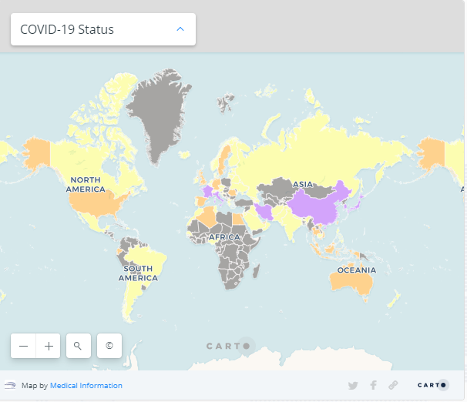

Legend

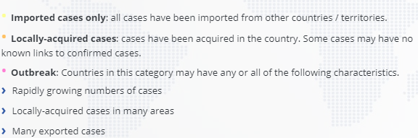

OUTBREAK
Mainland China | France | Iran | Italy | Japan
South Korea
IMPORTED AND LOCALLY ACQUIRED
Algeria | Hong Kong (China SAR) | Singapore | Taiwan (China) | United Kingdom
Australia | Germany | Spain | Thailand | United States
Ecuador | Malaysia | Sweden | United Arab Emirates | Vietnam
LOCALLY ACQUIRED
Egypt | Indonesia | Romania
IMPORTED ONLY
Afghanistan | Chile | Ireland | Nepal | San Marino
Andorra | Croatia | Israel | Netherlands | Saudi Arabia
Argentina | Czech Republic | Jordan | New Zealand | Senegal
Armenia | Denmark | Kuwait | Nigeria | Sri Lanka
Austria | Dominican Republic | Latvia | North Macedonia | Switzerland
Azerbaijan | Estonia | Lebanon | Norway | Tunisia
Bahrain | Finland | Lithuania | Oman | Ukraine
Belarus | Georgia | Luxembourg | Pakistan | Ukraine
Belgium | Greece | Macao (China SAR) | Philippines
Brazil | Iceland | Mexico | Portugal
Cambodia | India | Monaco | Qatar
Canada | Iraq | Morocco | Russia

ANALYSIS OF CHINA CASE DATA

Chart 2: Analysis of first 72,314 cases in China.

Data from China Center for Disease Control and Prevention
Published in New England Journal of Medicine

- 68% of cases were PCR confirmed
- 74% of cases were diagnosed in Hubei Province
- 85.8% reported exposure in Wuhan
- Mild: 80.9%
- Severe: 13.8%
- Critically ill: 4.7%
- Deaths: 2.3% among PCR confirmed
- All deaths were previously critical cases
- Male-to-female ratio: 1.06:1
- 1,688 healthcare workers infected
  - Severe: 14.6%
  - Fatal: 0.3%
Definitions:
Critically ill: Respiratory failure, septic shock, multi-organ dysfunction or failure
Severe: Respiratory rate 30/min, O2 sat < 93%, lung infiltrates >50% within 24-48 hours
Mild: non and mild pneumonia

Chart 3: Age distribution of Cases and Death

Mortality rate data from China CDC Weekly.
Graph prepared by Associate Professor Ian Mackay. Used with permission.
- Most cases occur between ages 20 and 69
- Relative sparing of children
- Deaths rapidly increase over age 60
This information is critical in understanding the most affected groups, planning mitigation strategies and for resource planning.

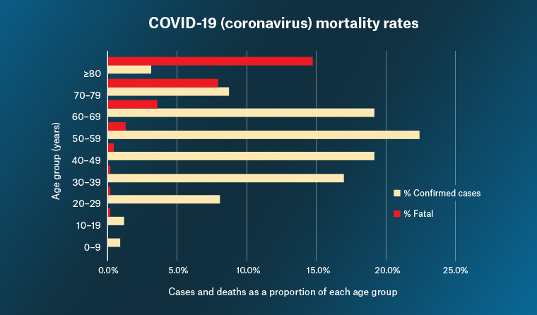

TRANSMISSION OF CORONAVIRUS CAN BE SLOWED OR STOPPED

China employed “industrial strength” public health measures which have controlled the transmission in all but Hubei Province and Beijing.

Chart 4: Daily confirmed cases in Mainland China. Data from WHO.

Chart 5: Contact tracing in Mainland China: Daily and Cumulative

The information comes from the official website of the National Health and Health Commission

Statistics:
- Total contacts traced so far: 666,397
- Maximum being traced at any one time: 189,660 on 8 February 2020
- Now: 36,432 under “medical observation”

IF YOU DON’T TEST, YOU WON’T FIND

IRAN: The outbreak in Iran remained undetected until a significant number of deaths were noted. On 26 February Iran reported 62 cases with 12 deaths, giving an apparent case fatality rate of 19.3%. In the last week, 883 new cases have been confirmed. Obviously, the amount of testing has dramatically increased. Current WHO figures for Iran are:
- Total cases: 1,501
- Deaths: 66
- Death rate: 4%

The average death rate for COVID-2019 is 1.5 – 2% and the higher death rate in Iran could be due to unrecognized cases and/or a lack of management capability for severe and critical cases.

USA: Until this week, the United States performed a limited number of tests for coronavirus for two main reasons:
- The test kits distributed by the CDC had a faulty reagent and had to be recalled
- Stringent FDA controls on who could be tested.
The limitation on testing in the US seems to have been related to the delayed confirmation of cases and deaths in Washington State and California.

These roadblocks seem now to have been overcome and Vice President Pence has today said that any American can now be tested for coronavirus. One million test kits should be available by the end of this week.

For comparison, China can do 1.6 million tests per week and South Korea have tested 65,000 people.

ITALY: Lombardy did not follow global guidelines of testing people showing symptoms but tracked and tested contacts. This caused intense debate in Italy as to whether Lombardy’s reaction appeared to make the situation appear worse than it was.

INDONESIA: Two cases have been confirmed in Indonesia. According to media, the cases are a mother and her daughter who are now hospitalised at Sulianti Saroso Infectious Disease Hospital in Jakarta. They had no travel history but the daughter had come in to contact with a visitor from Japan early February. The visitor travelled to Malaysia afterwards and was confirmed with COVID-19.

Indonesia has today committed to testing more for coronavirus. The Health Ministry has said it will now assign its regional labs to test people suspected of carrying the novel coronavirus

KOREA: Korea has begun drive-through testing for coronavirus.
In the northern city of Goyang, drivers pull in to a parking lot where they are met by health workers dressed in hazmat suits. Motorists then drive to several stations where nurses in protective plastic suits, masks and face shields register drivers, check their temperatures, and use swabs to take samples from their throats and nasal passages. Officials say it is safer and faster to test for the virus at the drive-through than in a hospital or health clinic.

UNITED KINGDOM: York Hospital has launched a new ‘drive through’ coronavirus testing service. The ‘See and Swab’ service, situated in a car park close to the hospital’s A&E department so that people do not need to come into A&E for testing. The samples are sent to the lab and the patients go home to await the results via a phone call.

REVERSE TRANSMISSION

News reports indicate that eight new coronavirus cases in China have been traced to Italy, the first time the virus has been discovered spreading back to China. The cases involved Chinese nationals in Qingtian county who had traveled from the city of Bergamo in the Lombardy region in Italy’s north. The group had close contact with a previously disclosed case and worked together at a restaurant. At least six of them took a flight from Milan to Shanghai then tested positive for the virus Monday after arriving in Qingtian.

AUTHORS

Dr Quarry MBBS, MSc (Community Health):
- Group Medical Director, Medical Intelligence, International SOS

Professor John Oxford PhD, DSc, FRCPE
- International Virologist & Author
- Blizzard Institute, Queen Mary College, London.
- Scientific Director, Oxford Media Medicine

