INTERNATIONAL SOS
CORONAVIRUS EXECUTIVE SUMMARY
11 MARCH 2020; 12.00 HRS GMT

Authors
- Dr Doug Quarry
- Professor John Oxford
International SOS now publishes a COVID-2019 Daily Case Summary.

The Executive Summary will be produced weekly and will contain in-depth analysis.

CASE SUMMARY

Table 1: Change in confirmed cases in the last seven days
Ordered by locations with the largest number of cases. Data from WHO.

The focus of the epidemic has moved away from China

LOCATION | 4-Mar-20 | 11-Mar-20 | WEEK  CHANGE
ITALY | 2,036 | 9,172 | 7,136
KOREA | 4,812 | 7,513 | 2,701
FRANCE | 191 | 1,402 | 1,211
SPAIN | 104 | 1,024 | 920
HUBEI | 67,127 | 67,760 | 633
USA | 64 | 472 | 408
JAPAN | 268 | 514 | 246
ML CHINA EX-HUBEI | 13,087 | 13,164 | 77
SINGAPORE | 108 | 160 | 52
HONG KONG | 101 | 115 | 14

Countries having their first cases of coronavirus: 72

Map 1: Map from International SOS Medical Information and Analysis team

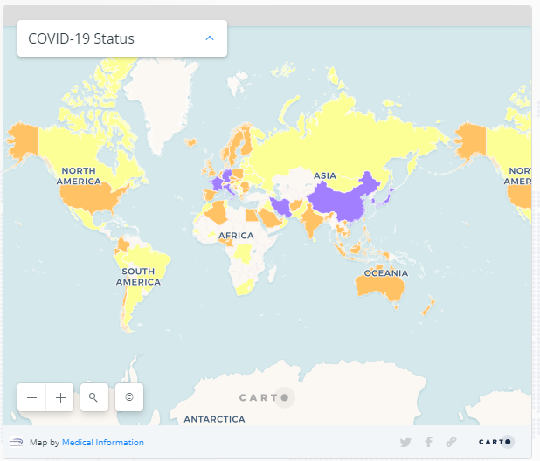

Legend
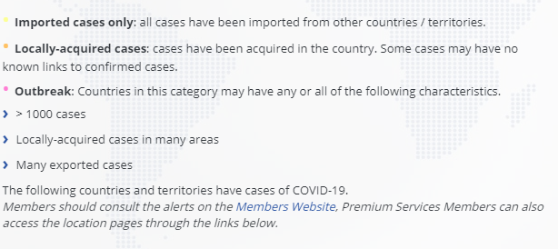
COUNTRY COVID-19 STATUS WITH INTERNATIONAL SOS MEDICAL RISK RATINGS

International SOS maintains Medical Risk Ratings for all Countries. Factors considered include: Standard of Medical Care, strength of Public Health system, level of Health Threats, Water potability, and difficulty of International Evacuation.

In general, we would expect Countries with HIGHER Medical Risk Ratings to be more vulnerable to an outbreak of coronavirus. Most of these countries have been receiving WHO support and can now test for the virus.

While this generalization makes sense, recent experience in South Korea and Italy shows that very dramatic outbreaks can occur even in LOW Medical Risk counties.

OUTBREAK
Mainland China | Iran | France | Germany | Italy
Japan | South Korea
IMPORTED AND LOCALLY ACQUIRED
Afghanistan | Algeria | Bangladesh | Cambodia | Cameroon
India | Indonesia | Nigeria | Palestine | Vietnam
Bosnia and Herzegovina | Bulgaria | Colombia | Costa Rica | Ecuador
Egypt | Lebanon | Malaysia | Maldives | Philippines
Romania | Romania | Slovakia | Thailand | Australia
Austria | Belgium | Chile | Croatia | Czech Republic
Denmark | Finland | Greece | Hong Kong | Iceland
Ireland | Israel | Macao | Netherlands | New Zealand
Norway | Poland | Portugal | Singapore | Spain
Sweden | Switzerland | Taiwan | United Arab Emirates | United Kingdom
United States
IMPORTED ONLY
Burkina Faso | Iraq | Armenia | Azerbaijan | Bhutan
DRC | Georgia | Mongolia | Nepal | Pakistan
Sri Lanka | Saint Martin | Togo | Albania | Argentina
Bahrain | Belarus | Brazil | Brunei | Cyprus
Dominican Republic | French Guiana | Jamaica | Jordan | Kuwait
Latvia | Lithuania | Mexico | Moldova | Morocco
Macedonia | Oman | Panama | Paraguay | Peru
Russia | Senegal | Serbia | Tunisia | Ukraine
Estonia | Gibraltar | Hungary | Luxembourg | Malta
Martinique | Monaco | Qatar | Slovenia | South Africa
LEGEND AND DEFINTIONS
EXTREME  MEDICAL  RISK | HIGH  MEDICAL  RISK | MEDIUM  MEDICAL  RISK | LOW  MEDICAL  RISK
FOCUS ON KOREA

Chart 1. Epidemic slows in Korea (as occurred in ML China)
Number of cases confirmed daily. Data from WHO.

Chart 2. Korea was also able to control the MERS-CoV outbreak in 2015
Data from: Korean Ministry of Health

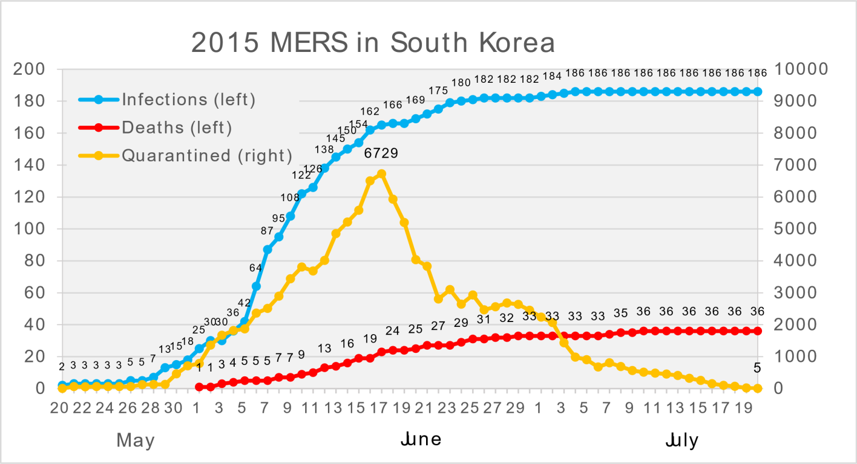
FOCUS ON ITALY

Chart 3. Epidemic has not yet peaked in Italy
Number of cases confirmed daily. Data from WHO.

PLEASE WATCH Dr. Giacomo Graselli, an intensivist coordinating the network of COVID-2019 ICUs in Lombardy. Dr Graselli describes the rapid spread of the coronavirus, as occurred with Wuhan, with medical facilities initially being overwhelmed.

Here is a brief summary of what he says.
- The situation in Lombardy is critical
- What happened in Lombardy was just like a bomb that exploded
- Lombardy is one of the richest areas in Europe. We have a very modern and efficient health system
- We were quickly overwhelmed by the mass of patients
- Please understand that, if you don’t control the spread of the disease, the disease will overwhelm your system.
- You must avoid a lot of people becoming ill at the same time
- You must teach the population to behave in a way to avoid the spread of the disease
- Italy is now putting in severe measures to control the spread of the disease.
- If you asked me two weeks ago whether we were going to have to create 500 new ICU beds and completely reorganise our hospital system, I would have said you were crazy
- In Lombardy, most of the patients died where more than 80 years old
- Some healthcare workers were infected in the beginning but that is now decreasing. Proper use of PPE is critical for healthcare workers
- Other countries now have more information and should be able to be better prepared
- I don’t understand why less people were infected and there is lower mortality in different regions and countries. Hopefully in other countries it is not behaving like this. Even in the surrounding regions they have lower cases numbers and lower mortality
ALSO READ THIS TWITTER THREAD: Dr Graselli’s description is confirmed by an intensivist/A&E/ER consultant currently in Northern Italy.

Interesting related links:

Why have there been so many deaths in Italy?

Italy extends emergency measures nationwide

Message received: Italians are staying at home

The clear warning here is that COVID-19 can spread very rapidly, and without warning, even in LOW Medical Risk countries. We must all be AS PREPARED AS POSSIBLE. Social distancing is the most important public intervention.

A PRIMER ON EPIDEMIOLOGY

With so many terms, ratios and percentages being quoted and studied, some clarity is needed. Mathematician Adam Kuchari helps here. More epi topics are explained in the article:
Case Fatality Rate:
“The problem with just dividing the total number of deaths and total number of cases is that it doesn’t account for unreported cases or the delay from illness to death. The delay is crucial: If 100 people arrive at hospital with Covid-19 on a given day, and all are currently still alive, it obviously doesn’t mean that the fatality rate is 0 percent. We need to wait until we know what happens to them eventually.”

One aspect not covered are Epidemic Curves:
The final report of the WHO-China Joint Mission is informative.

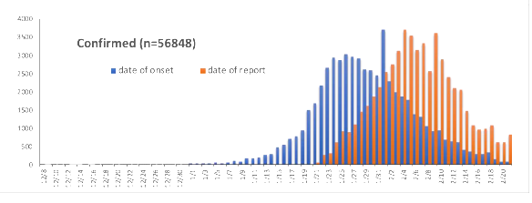
This chart shows two types of epidemic curves:
- Blue: Date of Onset
- Orange: Date of Report
In general, publicly available data report only on the “Date of Report” (= date case confirmed).
The date of onset of symptoms in China was on average 10-12 days earlier than the date of report. In addition, the date of infection would be 3-10 days earlier again (consider a range of incubation periods)

A VIEW FROM THE LAB

By Professor John Oxford
- In an excellent article Nature Microbiology, Edward Holmes from Sydney, dispels reports that the virus might mutate or even worse that it emerged as two classes, one worse than the other, with the former dying out early on in Wuhan leaving us with the less deadly version. Mr. Holmes emphasises that talk of mutation is science fiction akin to the Andromeda strain. Evolution of virulence is highly complex. Mutations are a natural part of the virus lifestyle and rarely impact outbreaks dramatically.
- Zhou et al in the Lancet on 9 March report on 191 patients from early in the Wuhan epidemic and conclude that the pathology is driven by age-related defects of B and T cell function along with excess production of type 2 cytokines. The result is a prolonged pro inflammatory response. Virus infection is leading to sepsis and in more than 50 percent of cases there are no bacteria. Viral RNA found in respiratory specimens for 20 days. The nucleotide analogue was being tested in a separate study showed a mean incubation of 5.1 days and 97 per cent of those who develop symptoms did so within 11.5 days. So, 101 out of 10,000 cases will develop symptoms after 24 days of quarantine.
- The UK Government has called for three million paid workers to help the NHS deal with the COVID-19 crisis and a new law will soon be enacted. The main plan is to treat people at home, where medically possible. The plan is to introduce certain measures at various stages as we move from containment to delay phase. It is also likely that different regions will be at different stages at the same time. Some may be unaffected. Think of that famous poster of Lord Kitchener indicating “Your Country Needs You!”

JOURNALS AND MORE

A pre-print paper from Germany indicates that COVID-19 can spread before it causes symptoms and can produce symptoms similar to the common cold

We do not yet know the importance of “tidal breathing” in the transmission of COVID-19. A 2018 study by Milton and the EMIT Consortium concluded “Lack of human data on influenza virus aerosol shedding fuels debate over the importance of airborne transmission. We provide overwhelming evidence that humans generate infectious aerosols and quantitative data to improve mathematical models of transmission and public health interventions. We show that sneezing is rare and not important for—and that coughing is not required for—influenza virus aerosolization. Our findings, that upper and lower airway infection are independent and that fine-particle exhaled aerosols reflect infection in the lung, opened a pathway for a deeper understanding of the human biology of influenza infection and transmission.”

How will country-based mitigation measures influence the course of the COVID-19 epidemic? Lancet March 9, 2020; Governments will not be able to minimise both deaths from coronavirus disease 2019 (COVID-19) and the economic impact of viral spread. Keeping mortality as low as possible will be the highest priority for individuals; hence governments must put in place measures to ameliorate the inevitable economic downturn. In our view, COVID-19 has developed into a pandemic, with small chains of transmission in many countries and large chains resulting in extensive spread in a few countries, such as Italy, Iran, South Korea, and Japan. Most countries are likely to have spread of COVID-19, at least in the early stages, before any mitigation measures have an impact.

The CDC has released “Implementation of Mitigation Strategies for communities with Local COVID-19 Transmission.” Appropriate “Actions” are suggested for different groups in the community according to the level and impact of community transmission. This structure forms the basis of all good pandemic plans.

US OSHA has released Guidance on Preparing Workplaces for COVID-19.

AUTHORS

Dr Quarry MBBS, MSc (Community Health):
- Group Medical Director, Medical Intelligence, International SOS

Professor John Oxford PhD, DSc, FRCPE
- International Virologist & Author
- Blizzard Institute, Queen Mary College, London.
- Scientific Director, Oxford Media Medicine

